**Assignment 6.1:**

Creating database named ‘custom’



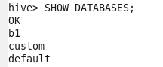

Creating a table named **temperature_data** inside **custom** database having below fields:

1. Date [mm-dd-yyyy] format
2. Zip code
3. Temperature

table to be loaded from comma-delimited file

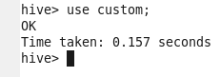



**temperature_data** is created and below command is used to show tables exist in **database**.

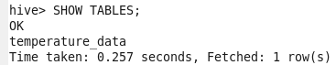

describing hive table [**temperature_data**] created:

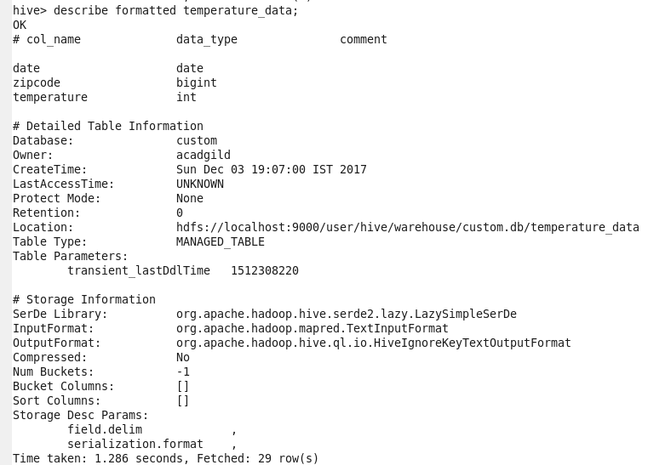

Loading data from dataset.txt (comma_delimited) in to hive table [**temperature_data**]



